**Opencart**

[**Test Plan**](https://docs.google.com/document/d/1ELiKi1wlJiS1o0ThL-3I2L6Tqzou03PF/edit#heading=h.30j0zll)[**1**](https://docs.google.com/document/d/1ELiKi1wlJiS1o0ThL-3I2L6Tqzou03PF/edit#heading=h.30j0zll)

[Objective](https://docs.google.com/document/d/1ELiKi1wlJiS1o0ThL-3I2L6Tqzou03PF/edit#heading=h.3znysh7) [2](https://docs.google.com/document/d/1ELiKi1wlJiS1o0ThL-3I2L6Tqzou03PF/edit#heading=h.3znysh7)

[Scope](https://docs.google.com/document/d/1ELiKi1wlJiS1o0ThL-3I2L6Tqzou03PF/edit#heading=h.2et92p0) [2](https://docs.google.com/document/d/1ELiKi1wlJiS1o0ThL-3I2L6Tqzou03PF/edit#heading=h.2et92p0)

[Inclusions](https://docs.google.com/document/d/1ELiKi1wlJiS1o0ThL-3I2L6Tqzou03PF/edit#heading=h.tyjcwt) [4](https://docs.google.com/document/d/1ELiKi1wlJiS1o0ThL-3I2L6Tqzou03PF/edit#heading=h.tyjcwt)

[Test Environments](https://docs.google.com/document/d/1ELiKi1wlJiS1o0ThL-3I2L6Tqzou03PF/edit#heading=h.3dy6vkm) [6](https://docs.google.com/document/d/1ELiKi1wlJiS1o0ThL-3I2L6Tqzou03PF/edit#heading=h.3dy6vkm)

[Defect Reporting Procedure](https://docs.google.com/document/d/1ELiKi1wlJiS1o0ThL-3I2L6Tqzou03PF/edit#heading=h.1t3h5sf) [7](https://docs.google.com/document/d/1ELiKi1wlJiS1o0ThL-3I2L6Tqzou03PF/edit#heading=h.1t3h5sf)

[Test Strategy](https://docs.google.com/document/d/1ELiKi1wlJiS1o0ThL-3I2L6Tqzou03PF/edit#heading=h.4d34og8) [8](https://docs.google.com/document/d/1ELiKi1wlJiS1o0ThL-3I2L6Tqzou03PF/edit#heading=h.4d34og8)

[Test Schedule](https://docs.google.com/document/d/1ELiKi1wlJiS1o0ThL-3I2L6Tqzou03PF/edit#heading=h.2s8eyo1) [9](https://docs.google.com/document/d/1ELiKi1wlJiS1o0ThL-3I2L6Tqzou03PF/edit#heading=h.2s8eyo1)

[Test Deliverables.](https://docs.google.com/document/d/1ELiKi1wlJiS1o0ThL-3I2L6Tqzou03PF/edit#heading=h.17dp8vu) [10](https://docs.google.com/document/d/1ELiKi1wlJiS1o0ThL-3I2L6Tqzou03PF/edit#heading=h.17dp8vu)

[Entry and Exit Criteria](https://docs.google.com/document/d/1ELiKi1wlJiS1o0ThL-3I2L6Tqzou03PF/edit#heading=h.3rdcrjn) [10](https://docs.google.com/document/d/1ELiKi1wlJiS1o0ThL-3I2L6Tqzou03PF/edit#heading=h.3rdcrjn)

[Entry Criteria:](https://docs.google.com/document/d/1ELiKi1wlJiS1o0ThL-3I2L6Tqzou03PF/edit#heading=h.26in1rg) [10](https://docs.google.com/document/d/1ELiKi1wlJiS1o0ThL-3I2L6Tqzou03PF/edit#heading=h.26in1rg)

[Exit Criteria:](https://docs.google.com/document/d/1ELiKi1wlJiS1o0ThL-3I2L6Tqzou03PF/edit#heading=h.lnxbz9) [11](https://docs.google.com/document/d/1ELiKi1wlJiS1o0ThL-3I2L6Tqzou03PF/edit#heading=h.lnxbz9)

[Test Execution](https://docs.google.com/document/d/1ELiKi1wlJiS1o0ThL-3I2L6Tqzou03PF/edit#heading=h.35nkun2) [11](https://docs.google.com/document/d/1ELiKi1wlJiS1o0ThL-3I2L6Tqzou03PF/edit#heading=h.35nkun2)

[Entry Criteria:](https://docs.google.com/document/d/1ELiKi1wlJiS1o0ThL-3I2L6Tqzou03PF/edit#heading=h.1ksv4uv) [11](https://docs.google.com/document/d/1ELiKi1wlJiS1o0ThL-3I2L6Tqzou03PF/edit#heading=h.1ksv4uv)

[Exit Criteria:](https://docs.google.com/document/d/1ELiKi1wlJiS1o0ThL-3I2L6Tqzou03PF/edit#heading=h.44sinio) [11](https://docs.google.com/document/d/1ELiKi1wlJiS1o0ThL-3I2L6Tqzou03PF/edit#heading=h.44sinio)

[Test Closure](https://docs.google.com/document/d/1ELiKi1wlJiS1o0ThL-3I2L6Tqzou03PF/edit#heading=h.2jxsxqh) [11](https://docs.google.com/document/d/1ELiKi1wlJiS1o0ThL-3I2L6Tqzou03PF/edit#heading=h.2jxsxqh)

[Entry Criteria:](https://docs.google.com/document/d/1ELiKi1wlJiS1o0ThL-3I2L6Tqzou03PF/edit#heading=h.z337ya) [11](https://docs.google.com/document/d/1ELiKi1wlJiS1o0ThL-3I2L6Tqzou03PF/edit#heading=h.z337ya)

[Exit Criteria:](https://docs.google.com/document/d/1ELiKi1wlJiS1o0ThL-3I2L6Tqzou03PF/edit#heading=h.3j2qqm3) [11](https://docs.google.com/document/d/1ELiKi1wlJiS1o0ThL-3I2L6Tqzou03PF/edit#heading=h.3j2qqm3)

[Tools](https://docs.google.com/document/d/1ELiKi1wlJiS1o0ThL-3I2L6Tqzou03PF/edit#heading=h.1y810tw) [11](https://docs.google.com/document/d/1ELiKi1wlJiS1o0ThL-3I2L6Tqzou03PF/edit#heading=h.1y810tw)

[Risks and Mitigations](https://docs.google.com/document/d/1ELiKi1wlJiS1o0ThL-3I2L6Tqzou03PF/edit#heading=h.4i7ojhp) [11](https://docs.google.com/document/d/1ELiKi1wlJiS1o0ThL-3I2L6Tqzou03PF/edit#heading=h.4i7ojhp)

[Approvals](https://docs.google.com/document/d/1ELiKi1wlJiS1o0ThL-3I2L6Tqzou03PF/edit#heading=h.2xcytpi) [12](https://docs.google.com/document/d/1ELiKi1wlJiS1o0ThL-3I2L6Tqzou03PF/edit#heading=h.2xcytpi)

## Objective

The objective is to test the end-to-end functionality, usability and performance of the ecommerce website and ensure it meets the business and technical requirements.

## Scope & Out of Scope

Web and mobile site Scope :

All customer workflows - search, browse, add to cart, checkout, payments

Account registration and management

Order management and tracking

Integration with payment gateways

Admin module and workflows

Web and mobile site Out of scope :

Physical fulfillment of orders

3rd party integrations not related to core functionality

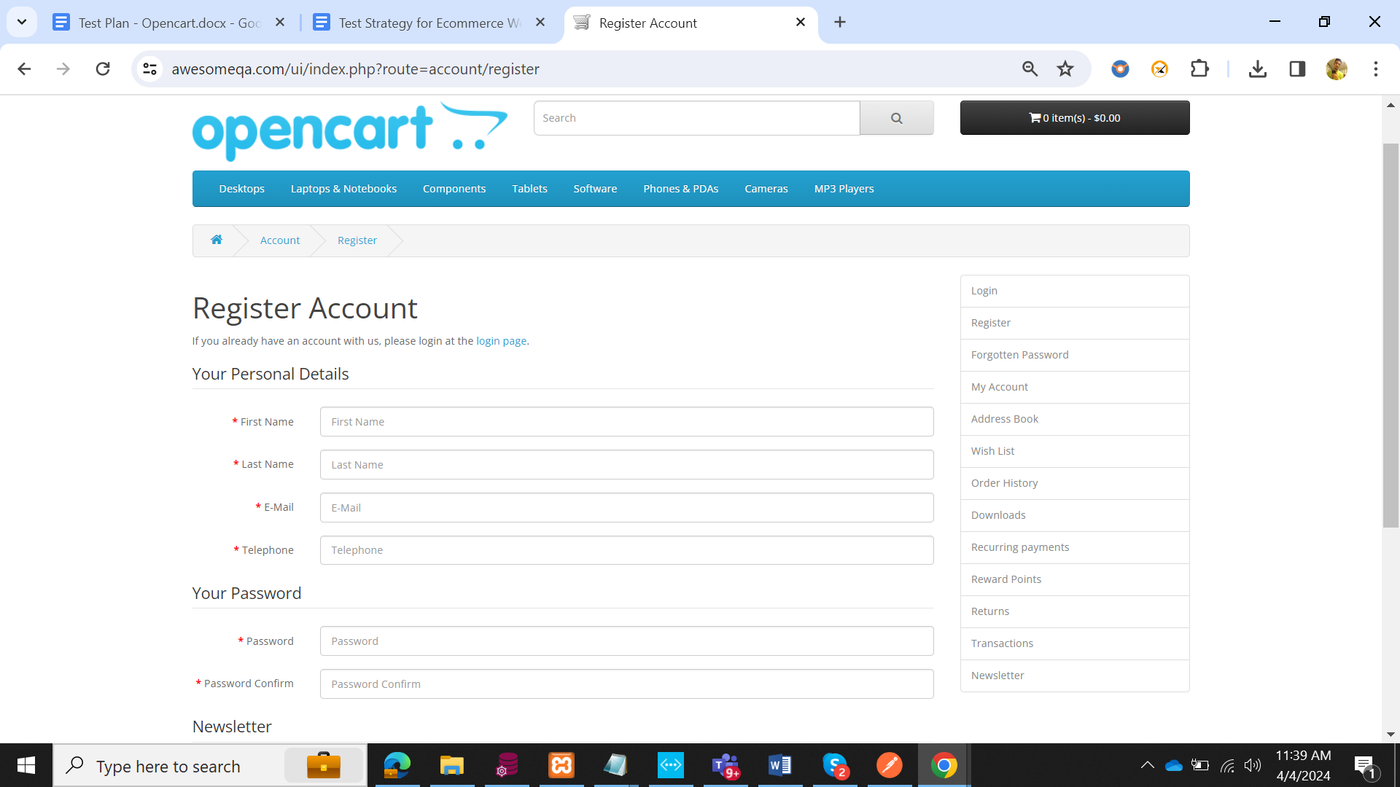

### Focus Areas

- Functional correctness of flows

- UI/navigation

- Performance

- load, stress and scalability

- Security - vulnerabilities, encryption

- Compatibility

- browsers, devices, OS

- Usability - ease of use, accessibility

### Approach

- Black box and white box testing techniques

- Automated test cases using Selenium and Appium

- Exploratory testing for key workflows

- Load testing with JMeter for at least 1000 concurrent users - Security testing for OWASP Top 10 vulnerabilities.

- Cross browser compatibility testing on IE, Chrome, Firefox - Ease of use evaluation with at least 10 end users.

### Deliverables

- Functional test cases and reports

- Performance test scripts and results - Security vulnerabilities report

- User acceptance testing report

- Test coverage and defect reports

- Automation regression suite

### Team & Schedule Testing

* team of 5 members needed for 4 months testing effort Proposed schedule:

- April: Functional and security testing

- May: Load/performance testing

- June: Compatibility testing, UAT - July: Regression testing

### Entry & Exit Criteria User stories

* to be tested must meet the defined 'Ready for Testing' criteria.
* Testing completes when all test cases execute with no critical defects outstanding.

### Risks

Delay in test environment availability

- Lack of access to third party payment systems

- Complex workflows may require more time and resources